

Spring 2026

Name: Adil Khan
Roll no: 2610-4011
Degree: BS AI

DEPARTMENT OF COMPUTER SCIENCE
SIR SYED CASE INSTITUTE OF TECHNOLOGY ISLAMABAD

Lab Mid Term
Task no 1:
#include <iostream>
using namespace std;

struct Product {
string name;
float price;
int quantity;
};

int main() {
Product p[3];
float totalBill = 0;

for (int i = 0; i < 3; i++) {
cout << "Enter details for Product " << i + 1 << endl;
cout << "Name: ";
cin >> p[i].name;
cout << "Price: ";
cin >> p[i].price;
cout << "Quantity: ";
cin >> p[i].quantity;
cout << endl;
}

cout << "\n--- Product Details ---\n";
for (int i = 0; i < 3; i++) {
float cost = p[i].price * p[i].quantity;

cout << "Product " << i + 1 << endl;
cout << "Name: " << p[i].name << endl;
cout << "Price: " << p[i].price << endl;
cout << "Quantity: " << p[i].quantity << endl;
cout << "Total Cost: " << cost << endl;
cout << "----------------------\n";

totalBill += cost;
}

cout << "\nFinal Total Bill: " << totalBill << endl;

return 0;
}

Output:
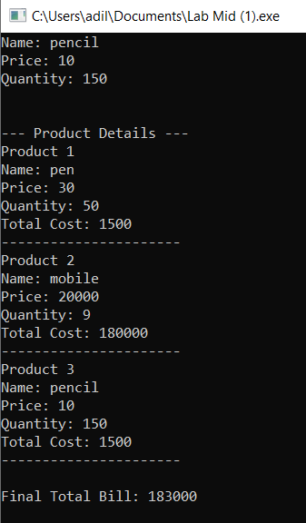

Task no 2:
#include <iostream>
using namespace std;

class Box {
private:
double length, breadth, height;

public:
Box(double l, double b, double h) {
this->length = l;
this->breadth = b;
this->height = h;
}

double calculateVolume() {
return this->length * this->breadth * this->height;
}
};

int main() {
Box box1(2,3,7);
Box box2(10,12,15);

cout << "Volume of Box 1: " << box1.calculateVolume() << endl;
cout << "Volume of Box 2: " << box2.calculateVolume() << endl;

return 0;
}
Output:
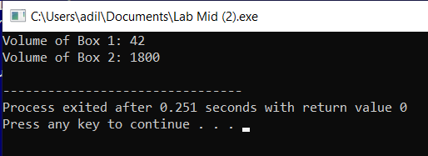

Task no 3:
#include <iostream>
using namespace std;

class Vehicle {
protected:
string brand;
int speed;

public:
Vehicle(string b, int s) {
brand = b;
speed = s;
cout << "Vehicle Constructor Called" << endl;
}

virtual void display() {
cout << "Brand: " << brand << endl;
cout << "Speed: " << speed << endl;
}

virtual void start() {
cout << "Vehicle is starting..." << endl;
}
};

class Car : public Vehicle {
private:
string fuelType;

public:
Car(string b, int s, string f) : Vehicle(b, s) {
fuelType = f;
cout << "Car Constructor Called" << endl;
}

void display() {
Vehicle::display();
cout << "Fuel Type: " << fuelType << endl;
}

void start() {
cout << "Car is starting with " << fuelType << " engine..." << endl;
}
};

int main() {
string brand, fuel;
int speed;

cout << "Enter Brand: ";
cin >> brand;

cout << "Enter Speed: ";
cin >> speed;

cout << "Enter Fuel Type: ";
cin >> fuel;

Car c(brand, speed, fuel);

cout << "\n--- Display Details ---" << endl;
c.display();

cout << "\n--- Start Function ---" << endl;
c.start();

return 0;
}

Output:
